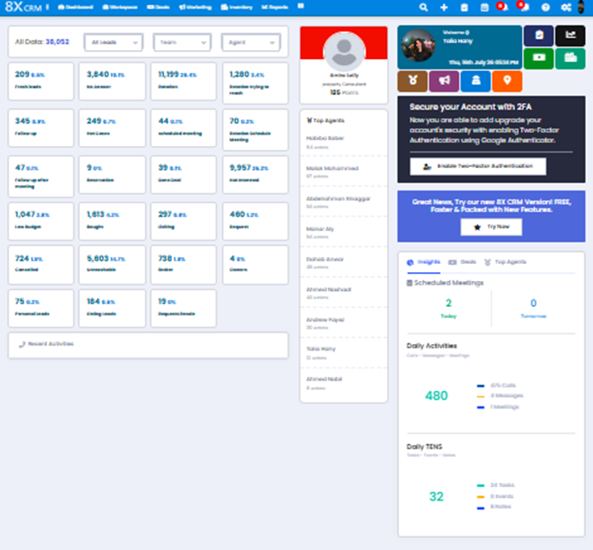

Crm Main Bar
where it includes ( 8xcrm =Name)
3 horizontal dots
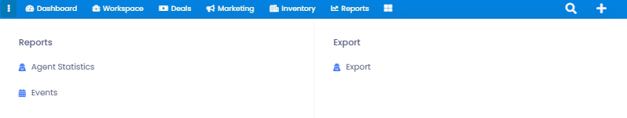
when clicked on shows
Reports
Agent statistics
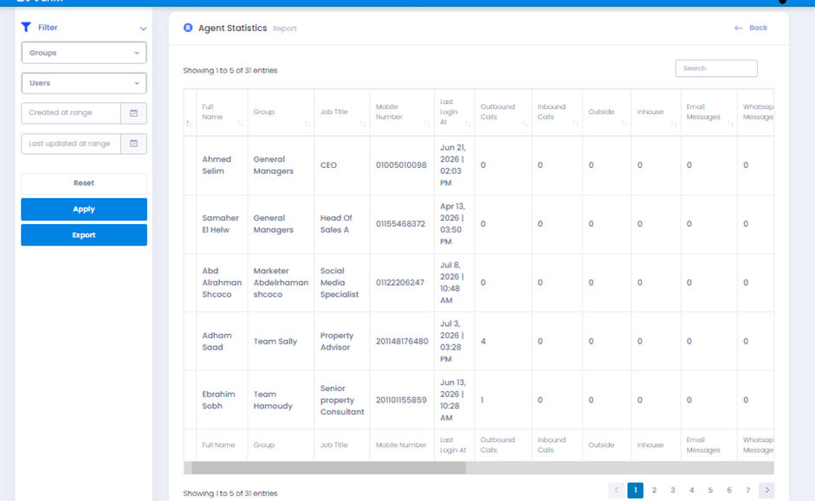
we have Filter by groups and agents
creation range – last updated range
its another form for reports shows agent’s day work
Events
it showes all events (schedule meetings action ( AKA meeting types)
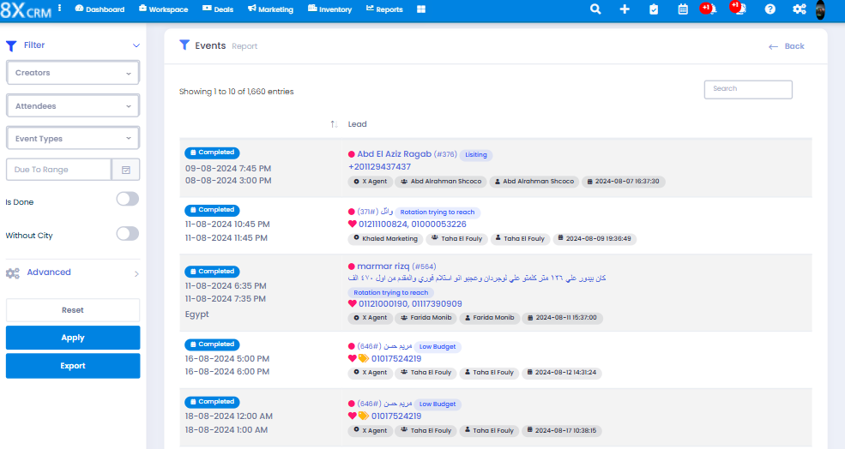
Creator - attendees - Event Type - Date Range
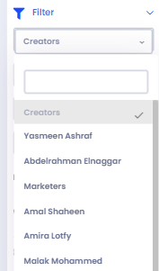 | 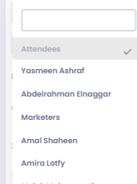 | 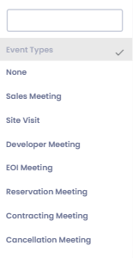 | 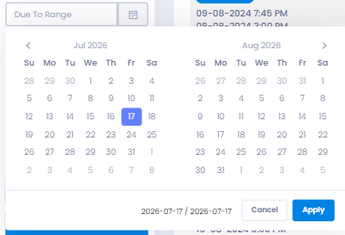
is done ( For done meetings)
City is kinda optional
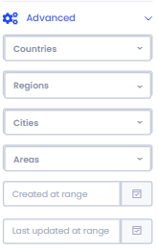 | 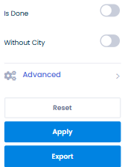
Reset - To Erase Data
Apply & Export
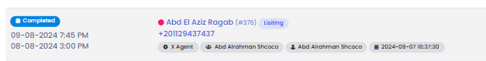
here shows the lead with its completeted Action
Date - Source - Agent
Name & number
when clicked on , it will direct us to the lead
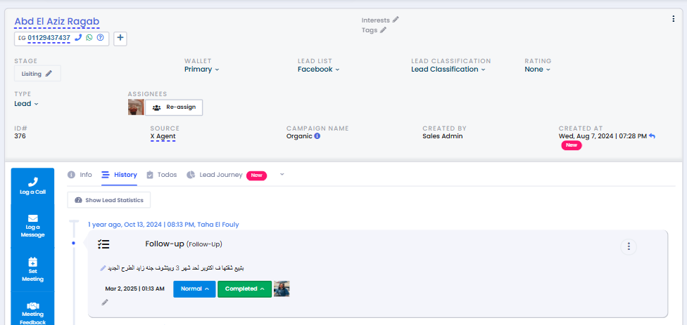
then Export
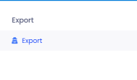
Where we can upload data from crm so we can print it
Export Request - Filter
if we wanna know who did the action , when or what source , intrest ,etc....
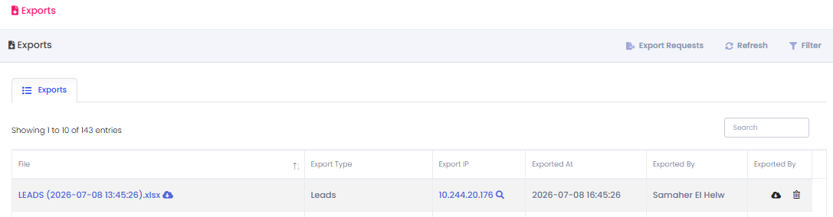
File name export type Export IP Date By who icons to
Type Of Ledas upload or delete

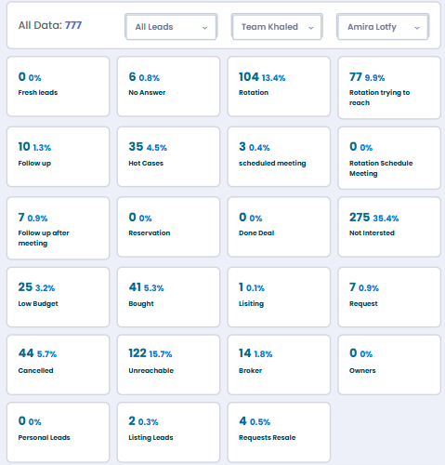
by Selecting Team Khaled - Agent Amira , we will see all the leads count in stags
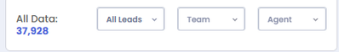
--- Dashboard Selection ------ All Leads Where we can select ( Warm – Cold -All leads) - Team ( For Team Selection) - Agent (For Agent selection)
then all the stages under each other
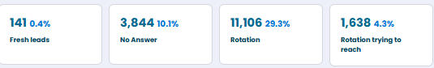
At the bottom we find Recent Activity Calls
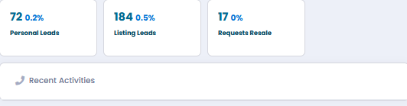
when clicked on it
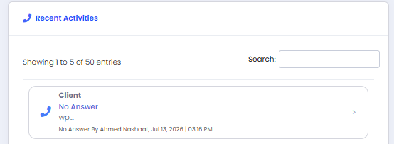
we find all recent activites for leads + the Call Action + feedback + Search Bar
then Agent + Date & Time
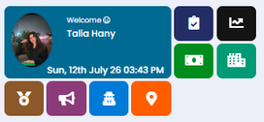

1 - Profile ( Date – Picture – Title )
top Agents
Plus the icon
title
points
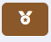
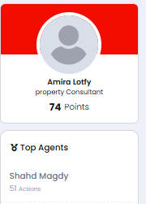 | 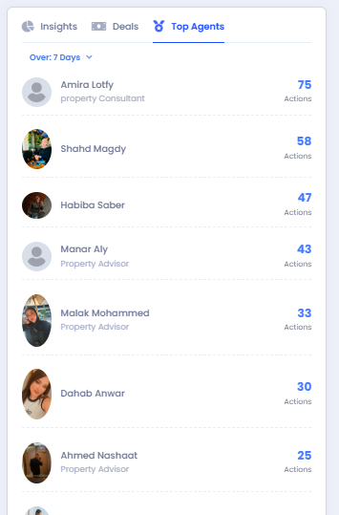

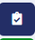

2- Todo’swhen clicked on – Follow up (Action) – (Schedule Meeting)
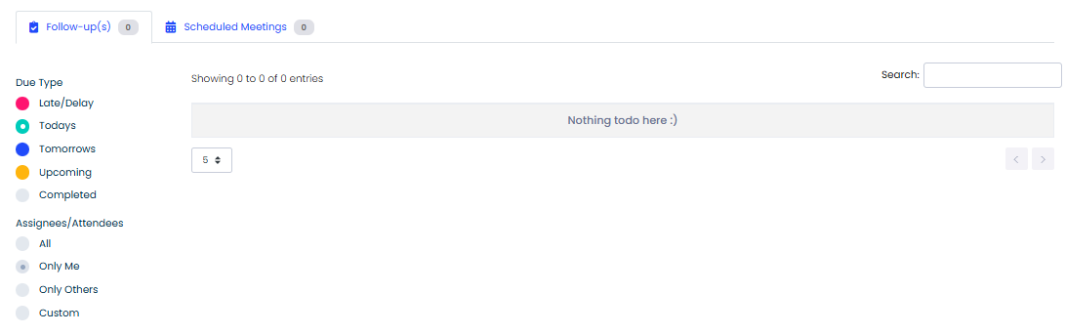
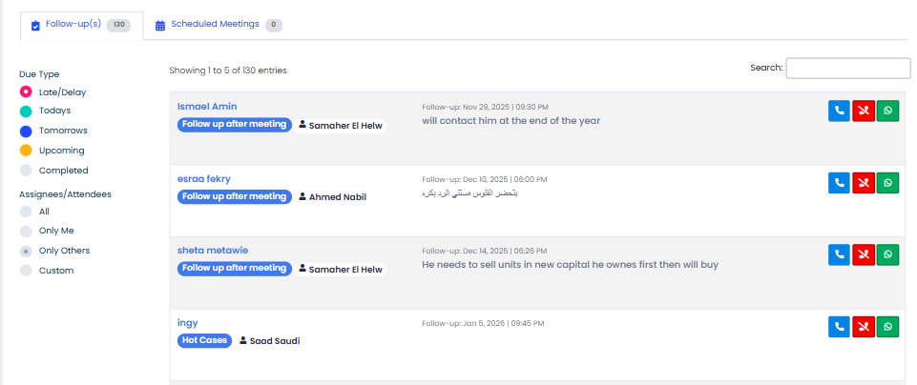
– By selcting Follow ups , then Delay and only other
it shows 130 leads late follow ups for Agents except me
-Due type ( where u can choose the date of Late or delay – todays – tomorrows – upcoming and completed -follow ups Assignes \ Attendees all – all agents only me ( user) only other ( all except user )
- custoum ( where I can select agent
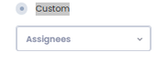
Search – where I can search for a lead name – number – agent
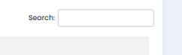
also by clicking on
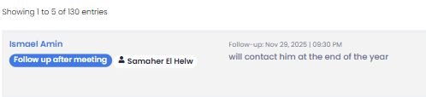
it will direct me to the lead ( all info + history )
 | 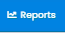
3-Reports Icons
Directs you to
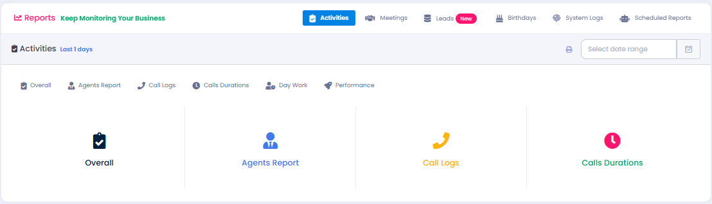
1- Overall
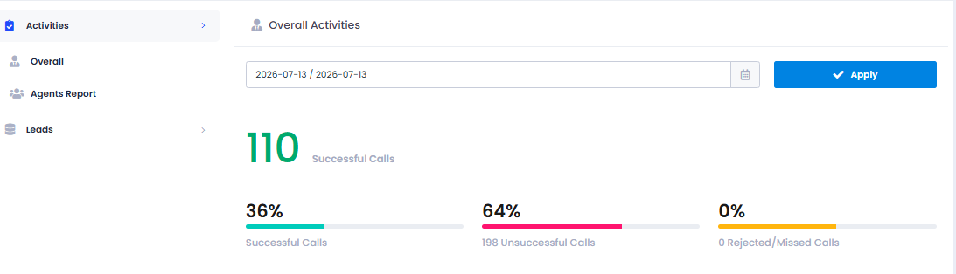
where i can select day date or Date Range
and it shows bunch of statistics ( Calls - meeting -Tasks- Messages ,etc)
2- Agent Report
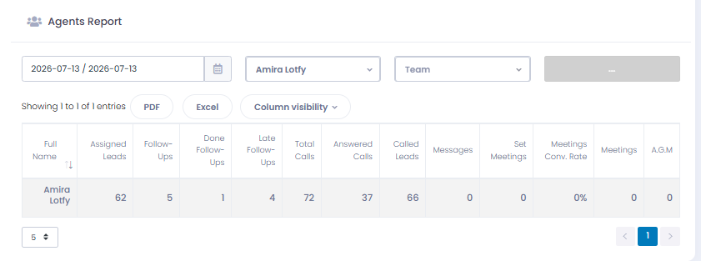
where i can select Date or Date range + Agent ( Amira )
will bring all his activites on crm
3- Call Logs
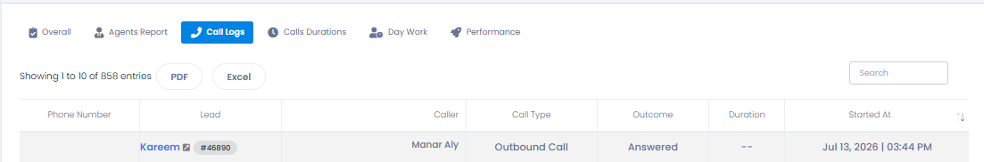
All cal logs on crm
4-Call Durartion
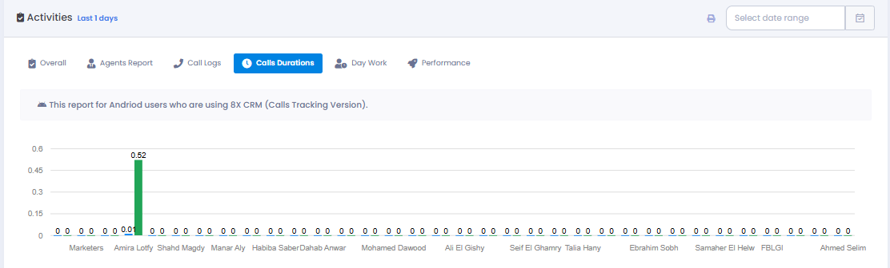
with a Date Range bar
all crm users
+ Duration of a call
5-Day Work
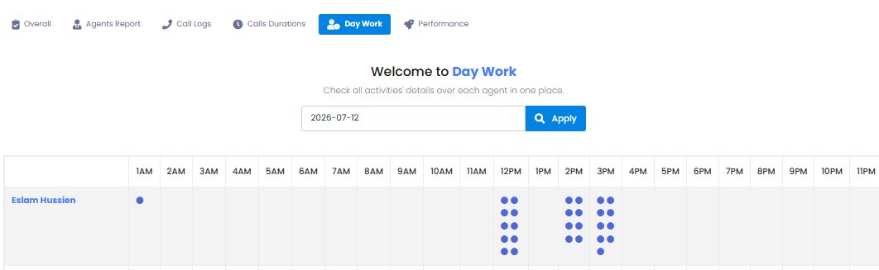
Date range + All agents with a time for actions
which let us know the peak hour for every agents’s work
6-Performance
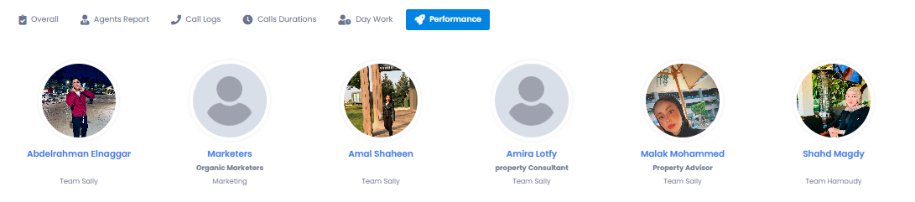
we can select time range then if we clicked on any agent
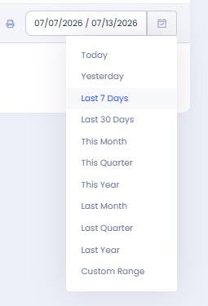
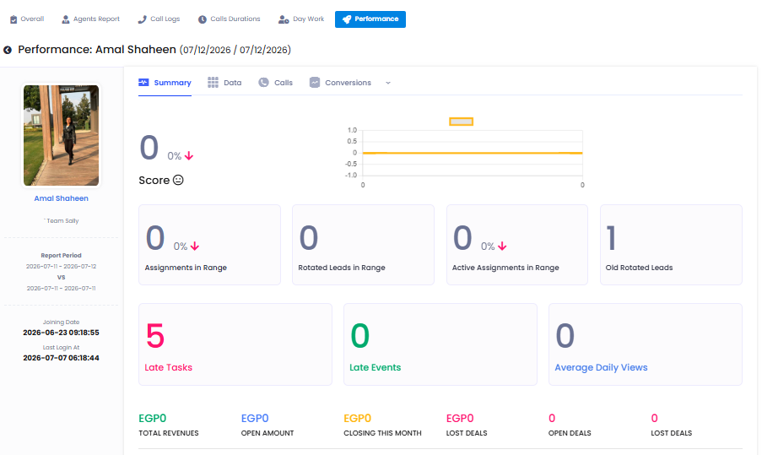
we can find another way for a performance report with a bunch of statistics
2-meetings
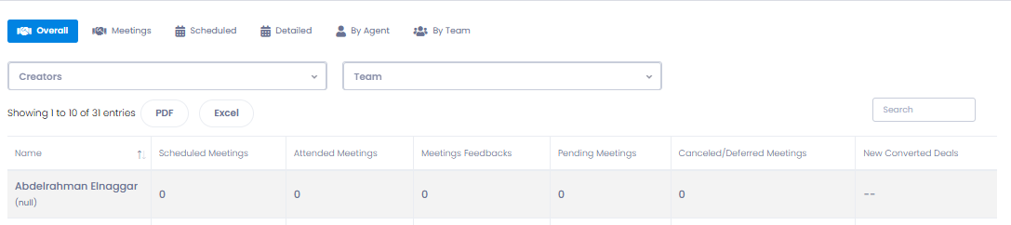
Creator + Agent Selection
3-Leads Report
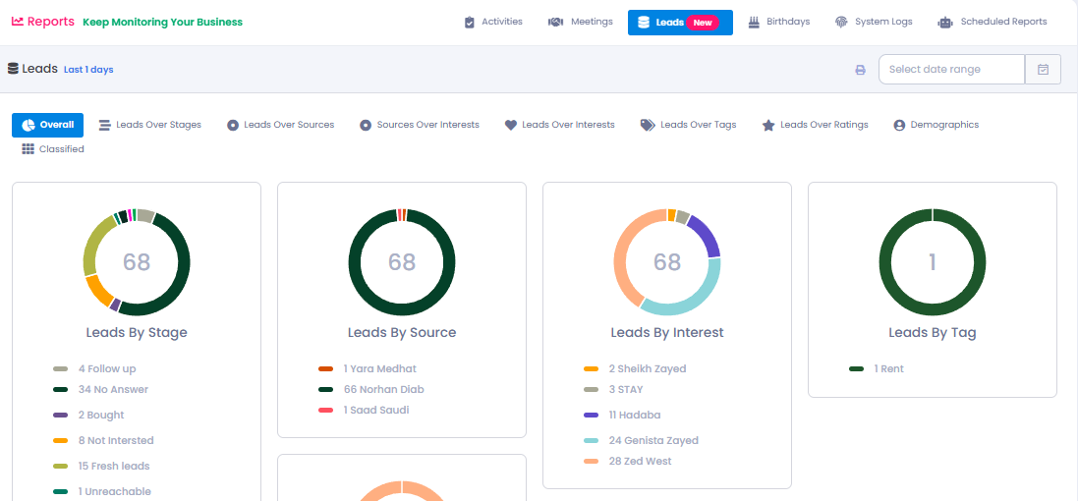
we can find an overall statistics report
leads over stage
leads over source
source over intrest
leads over intrest
+ a date range bar
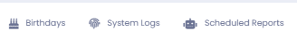
as for these we dont use them much actually
3- Deals Icons
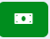

it will direct you to
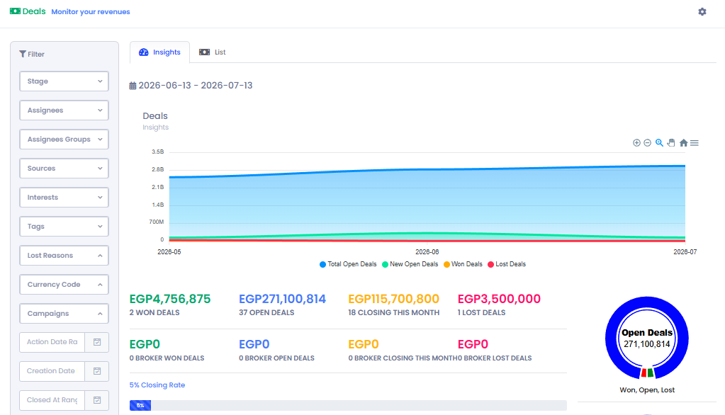
insights for our deals
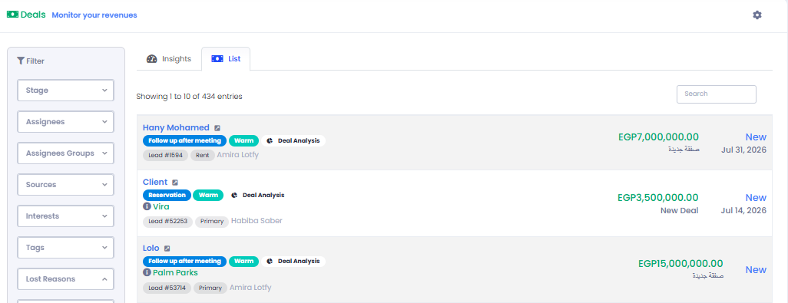
lists for every new deal Action Made by agent and Its lead
Filters where it helps us into reports or searching for a lead or analysis
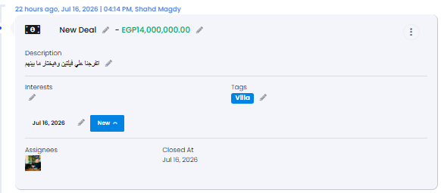 | 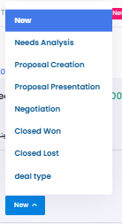
we need to add an action to close old deals to close the action
Closed lost or won
4- INVENTORY


these two icons will direct us to our inventory
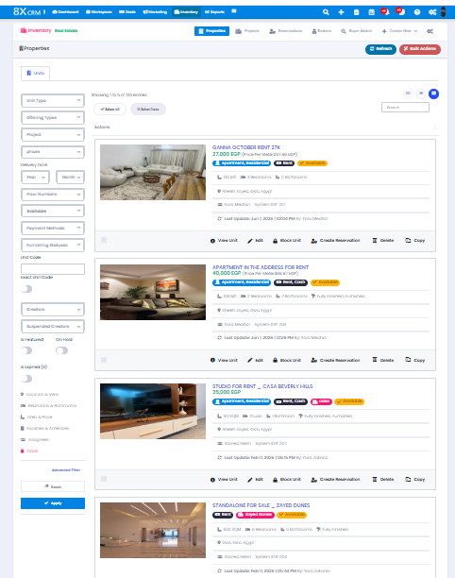
First
unit details
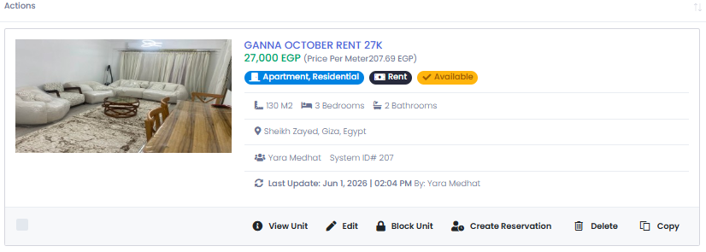
when clicked on
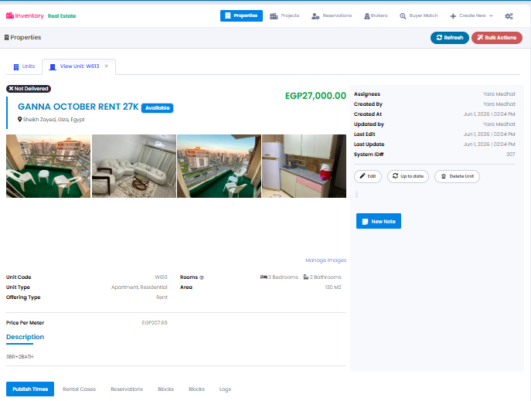
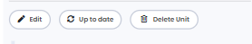

here we can edit - update and delete
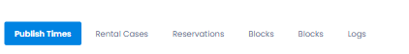
publish time is the most important or most usable from here
CReate Publish time
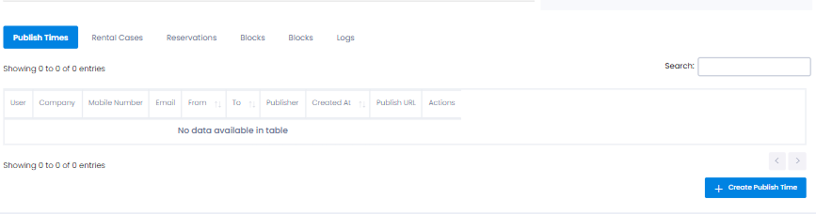
when we chose all details it creates a publish link
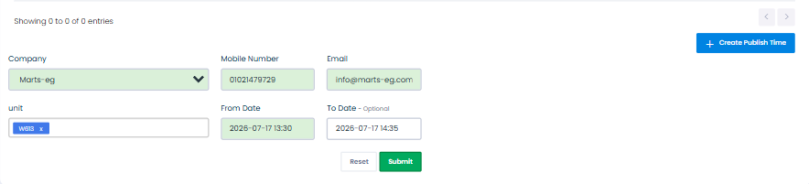
publish URL
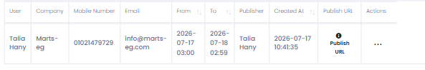
we cand dend it to client or we can post it on facebook to genertae leads from get in touch
client will type his info and will be direct on crm
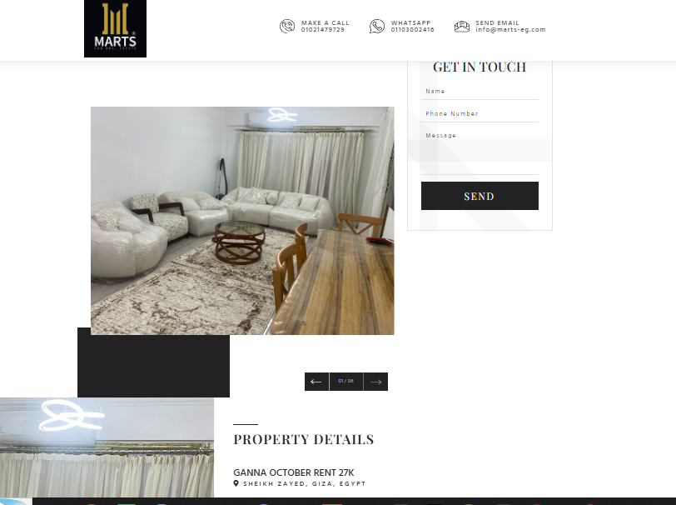
then how to add unit
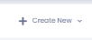 | 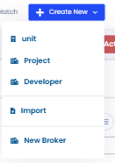
select unit
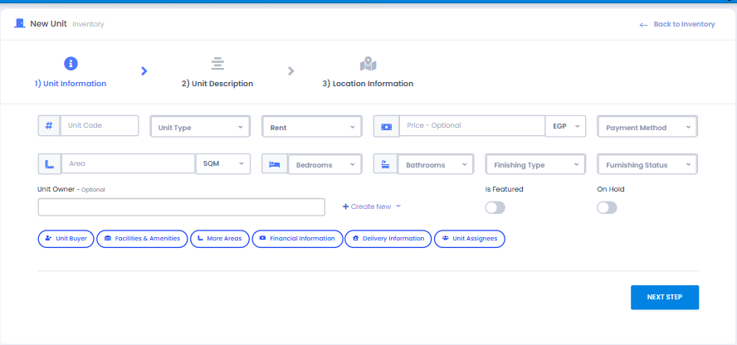
then fill info
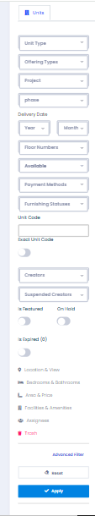
here we cand search by filters for any unit
5 - Markrting
 | 
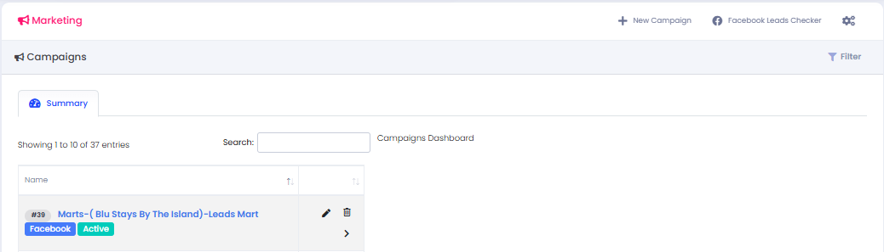
we will find all acampaigns
Search Bar
Filters
+ New Campaign “
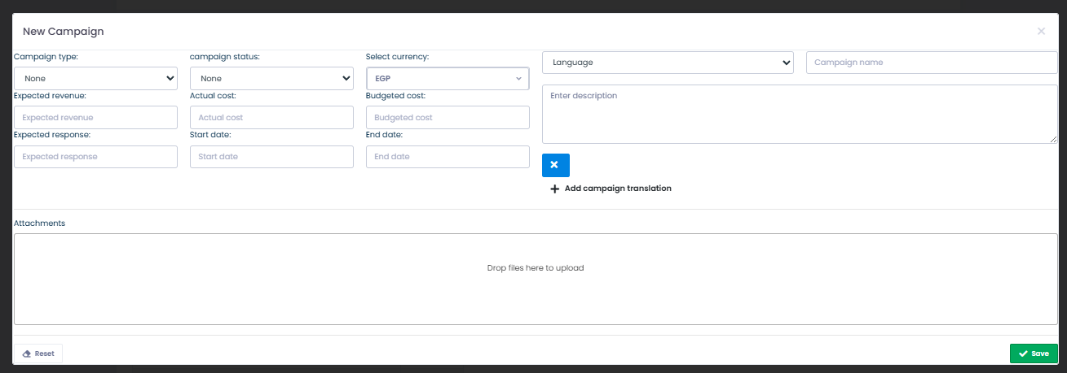
6- check ins& Out


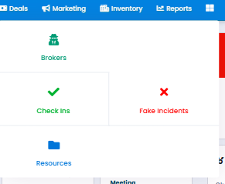
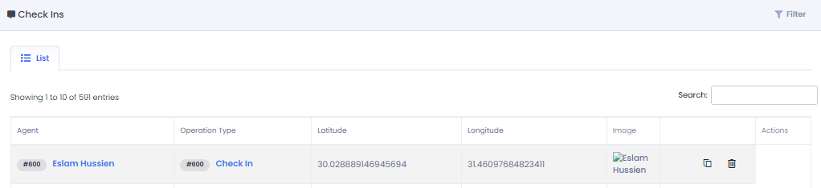
we can find all checkn’s & out’s on every lead
it lets us know the agent,s meeting time and loctation
if we Clicked on check in we will find
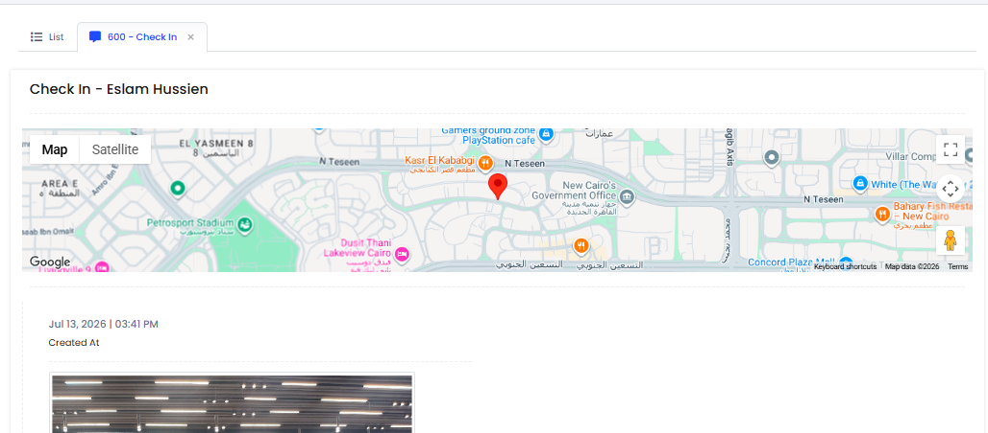
location
date & time
agent
picture
Workspace
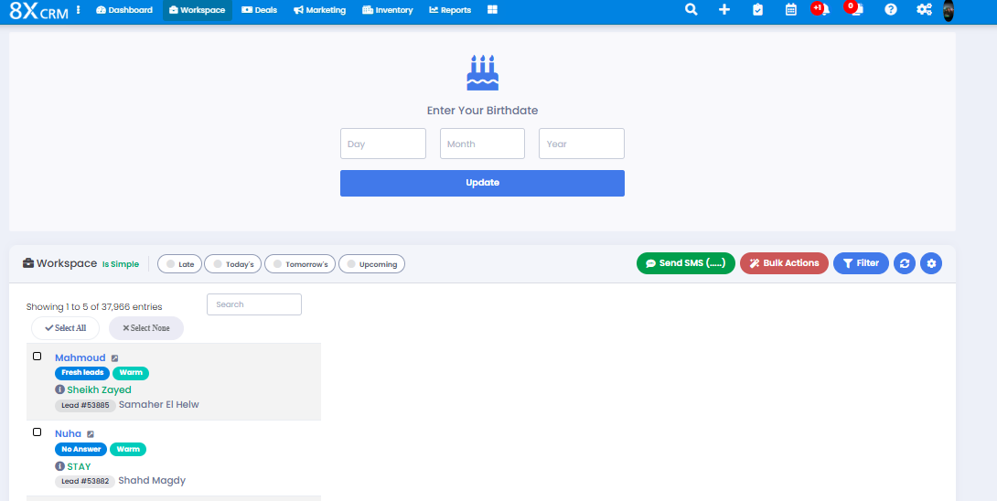
First we have an easy access to
( Late - Todays- Tomorrows- Upcoming)
example on late actions
here we can select all or none
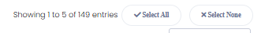
here we can select a value
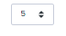

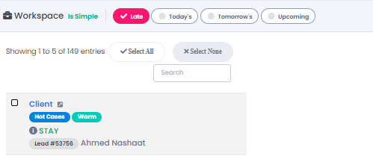
we have almost 150 late actions
and so one with the rest
on the other side
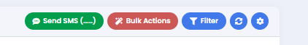
1- sms where we can send sms to a selected number of leads
2-Bulk Actions
all the add Actions we might as well do remove ( For intrests - tags - campaign - lead list - wallets - Ratings ... etc )
a lot of actions where we can select a number of leads to make one actions once and for a quantity of leads
one thing we wanna do is a button ( Mark all todos as complete ) its in the new version where i can select Ex: No Answer For Agent X ) sekect + bulk Mark all todos as complete
where it closes all the delayed actions on stages that are not potential or made incorreclty by agent
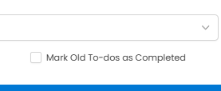
another is the undo action
we can do a history for bulk Actions where we can undo it
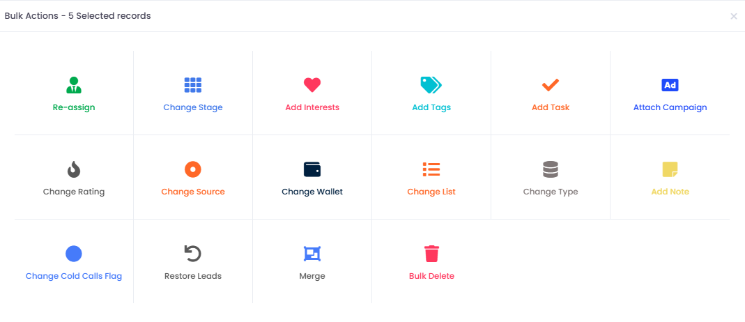
1 Reassign
Re-assign to anothe Agent
hide history
change stage
+ the one we wanna do ( Mark all todos as Complete)
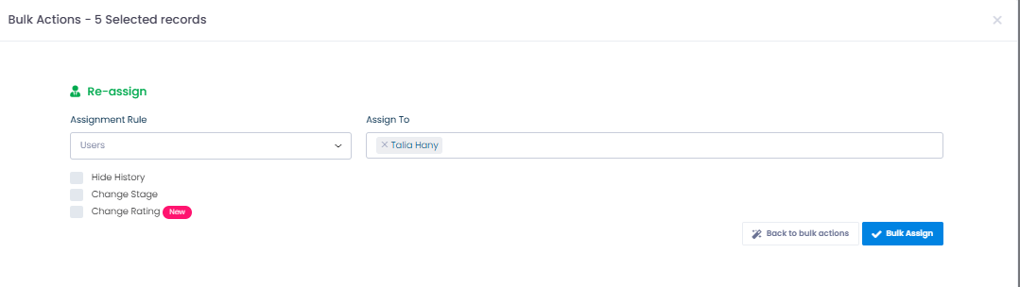
2- Change stage
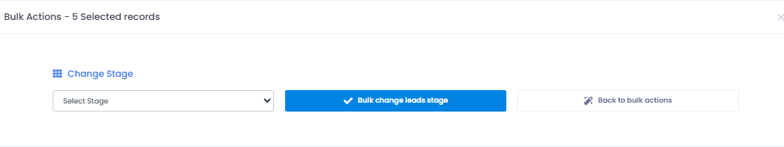
3- Change stage
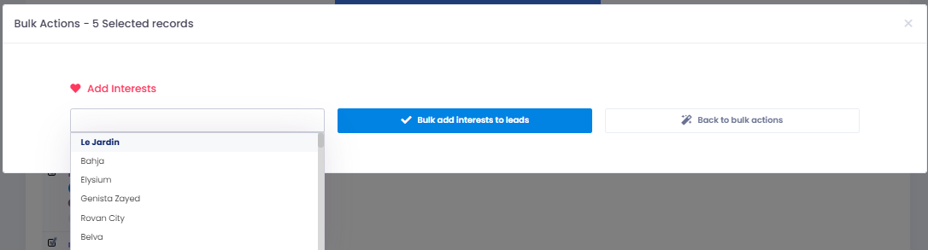
4- Tags
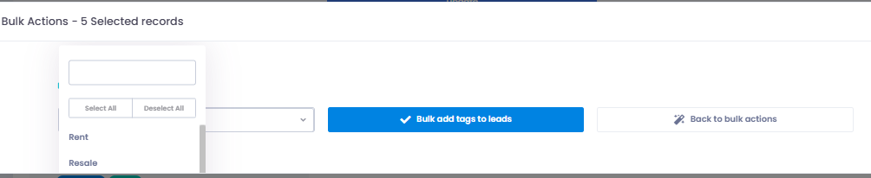
5- Add Tasks
where we can select a number of leads to make a new task on it so agent can be reminded to take action or follow up
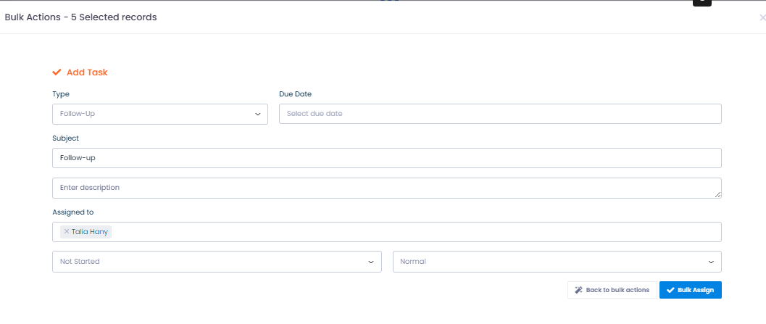
also we might as well add a bulk nudge or notification action ( New Version )
where we can select a number of leads make bulk Nudge and it appers as a task or follow up to make agent take action on lead
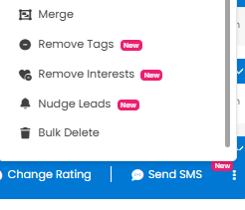
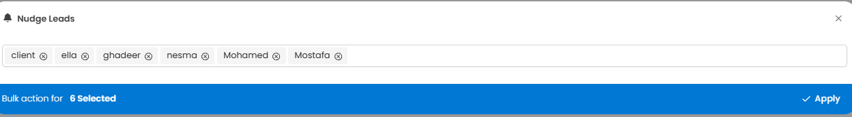
6- Add Campaign
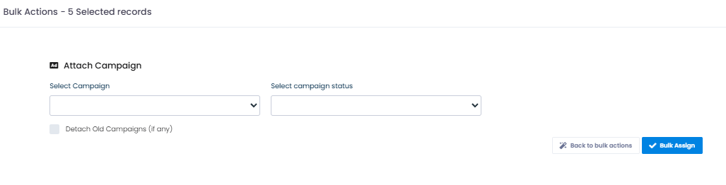
7- Change Rating ( Warm- Hot - cold )
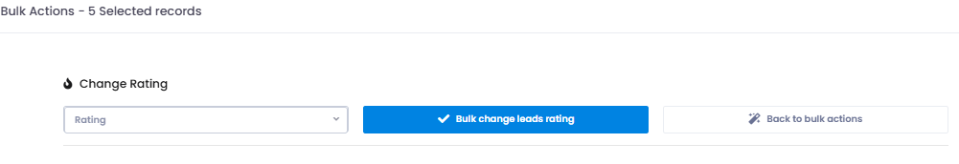
8-Change source
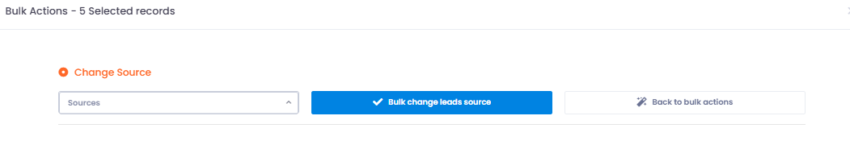
9- Change wallet
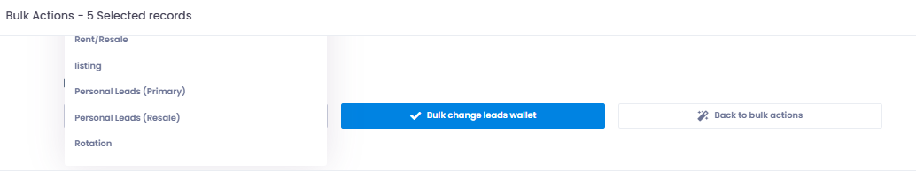
10 - Add bulk Note
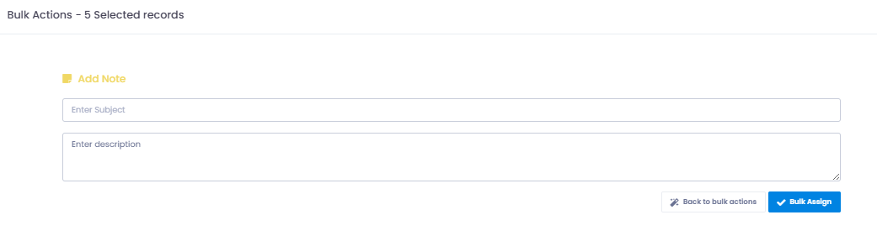
11- Merge leads
Rarely done as a bulk
For dublicated leads
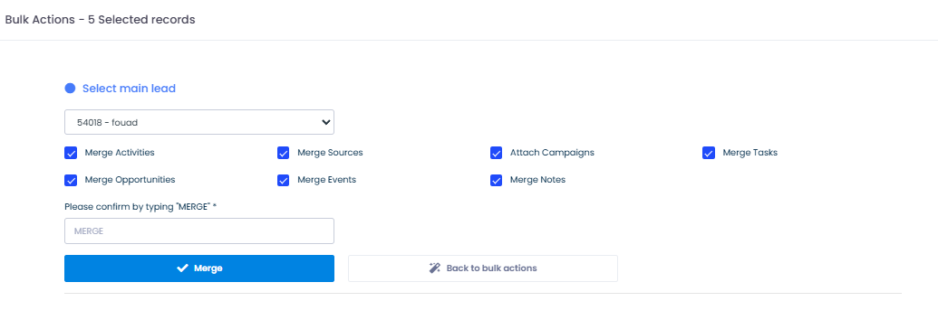
12- Bulk Delete
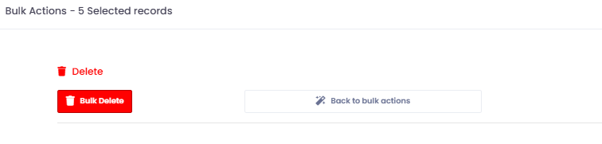

3- Filters
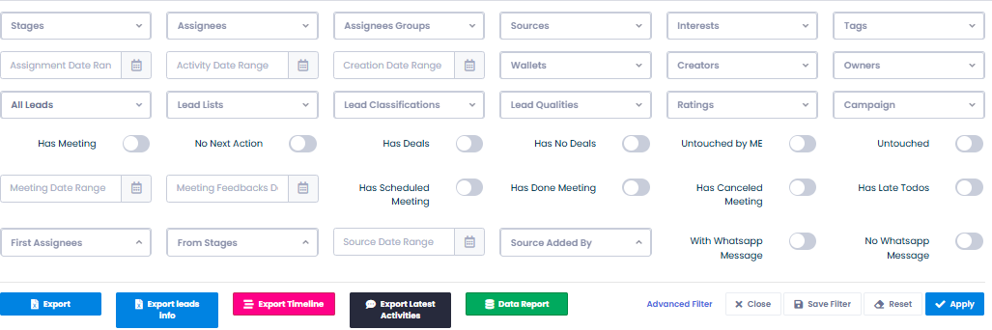
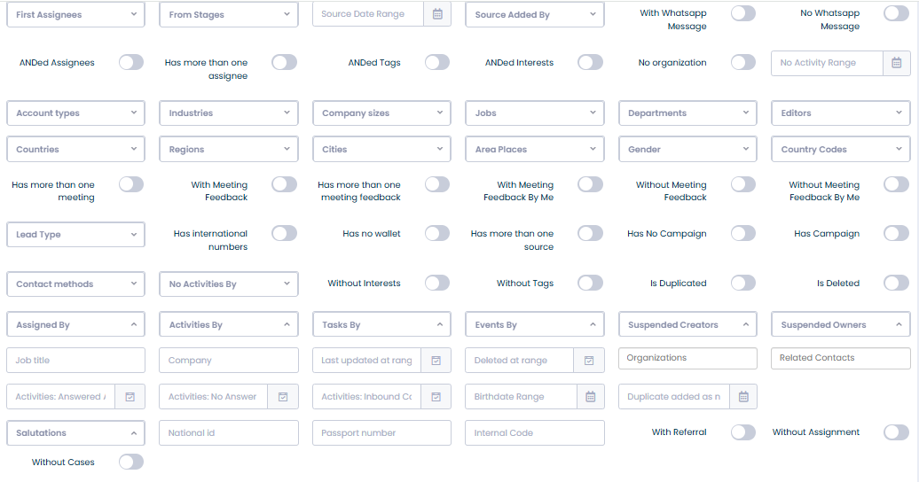
helps us with analysis and reports
we wanna add
Agent and stage
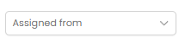
the export bar
1 export leads
2 leads Info
3 timeline
4 Data Report
shows all stages for a selected filters in simple way
Stage - number - agent
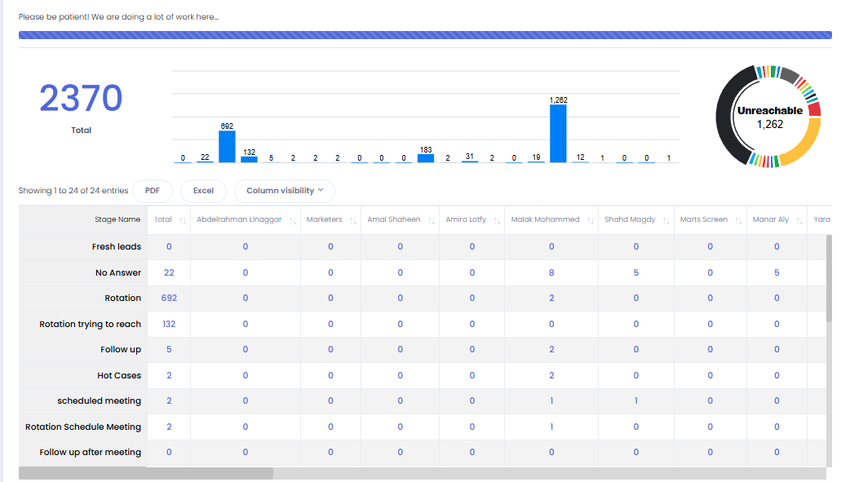

1 Search Bar
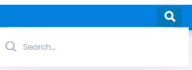
2- Plus Sign
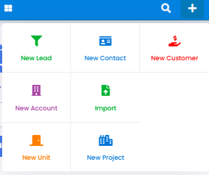
we only use
1 new lead
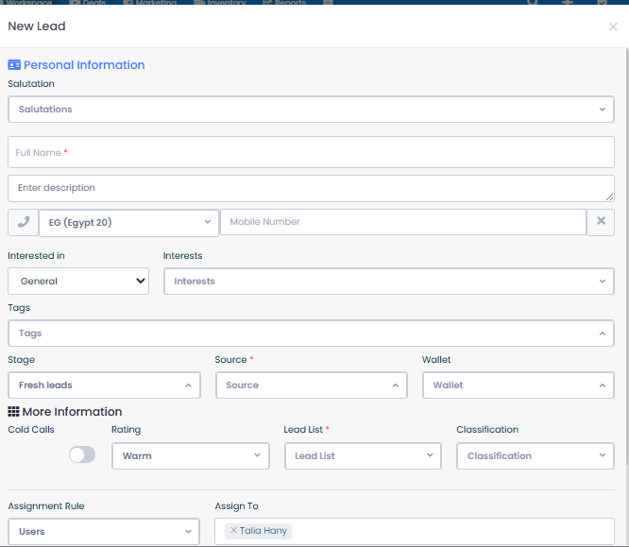
2 Import For bulk Leads
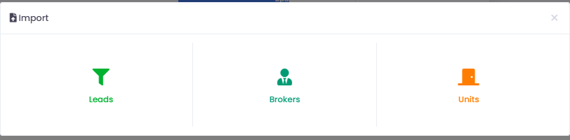
then we select Leads
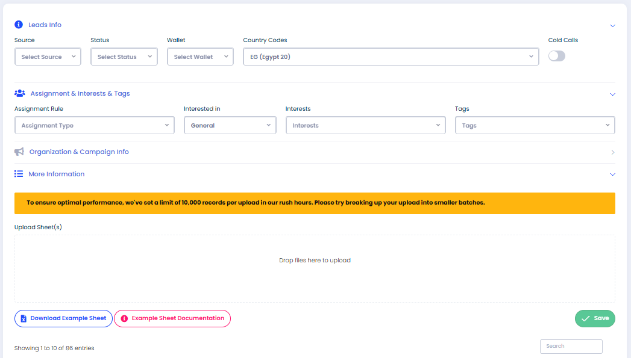
3 New Unit
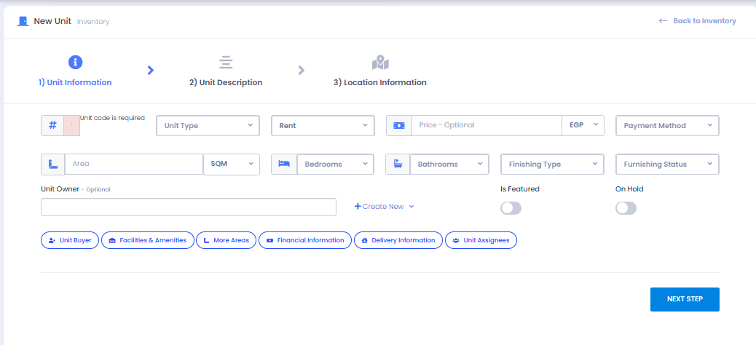
Notifications
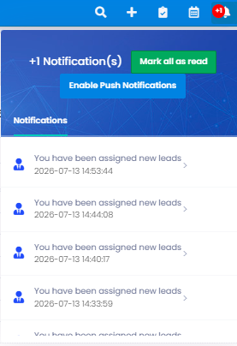
- Dublication
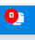
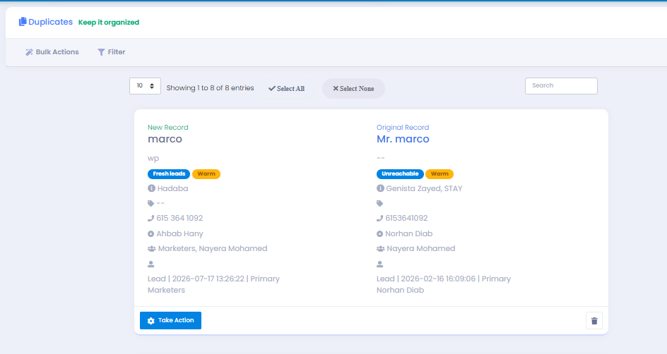
handeled by take action
Select Action
1- Add as new ( we add lead again if it between resale and primamry Or Two personal source
2 - Reassign ( fresh lead - another leads needs to be rotated )
3- Merge Lead ( if there is no diffrence and no need to re-assign
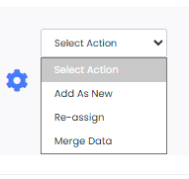 | 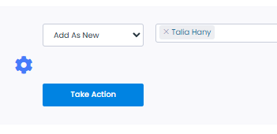
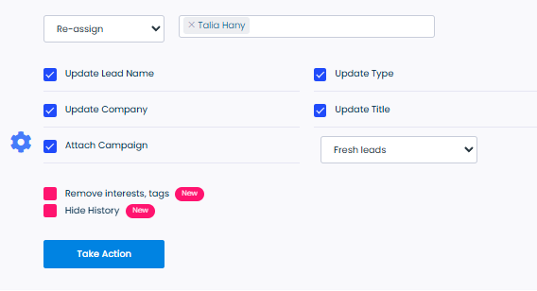 | 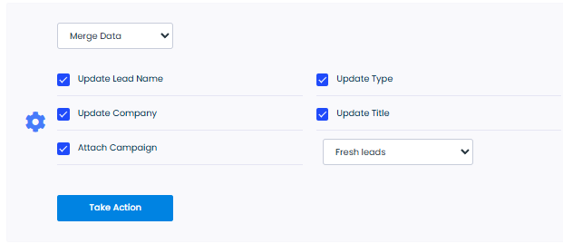

CRM Settings + Profile
showing the first one - Manage intrest + Add
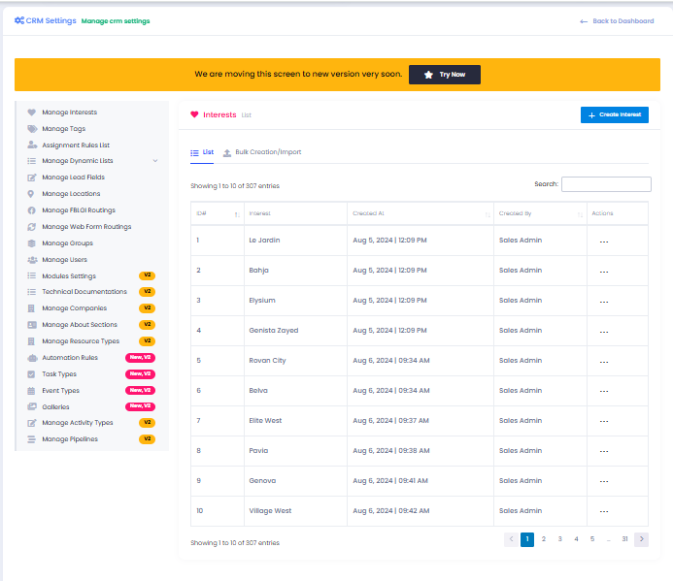
showing the first one - Mange intrest + Add
2- Tags
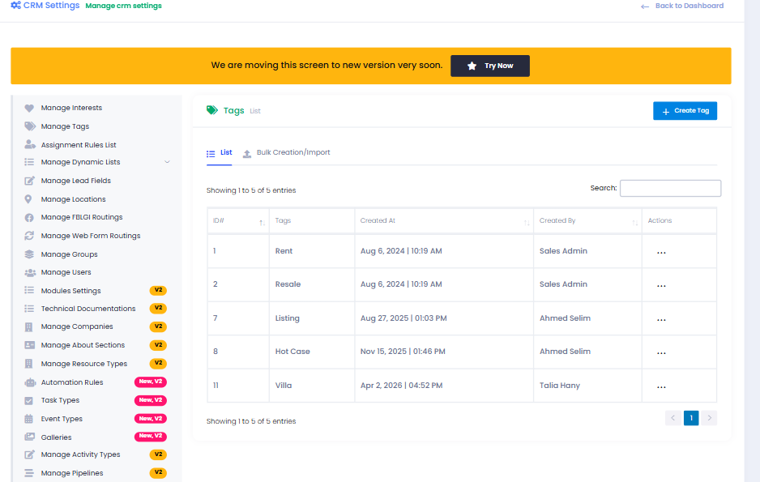
3 - Assigmnent Rule ( AKA automation New Version )
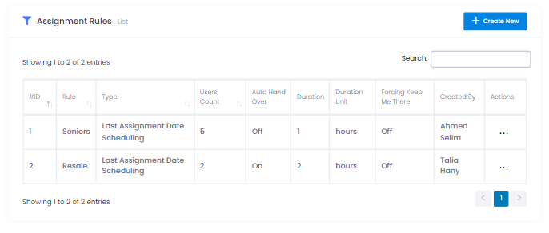

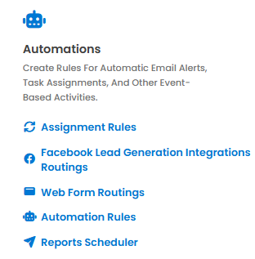 | 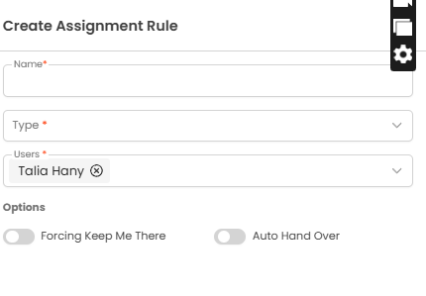
Dynamic Lists
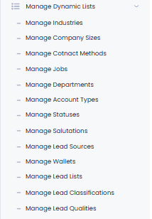
for wallets - sources - tags ...etc
GRoups
made with permissions to acesses different variations and authorities
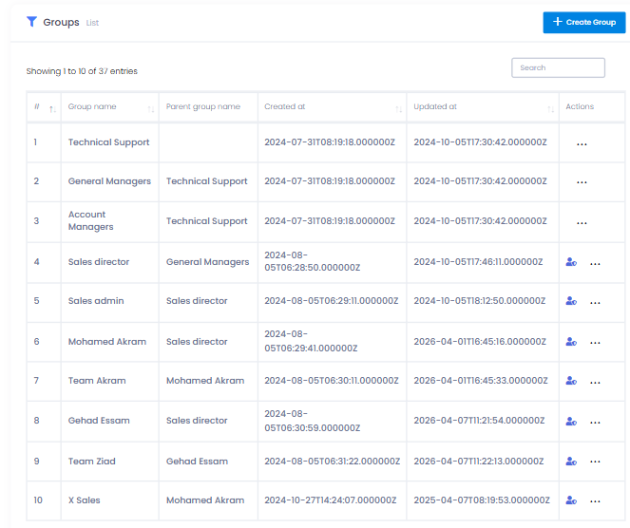
users
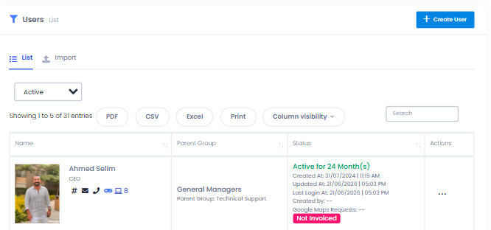
Create user
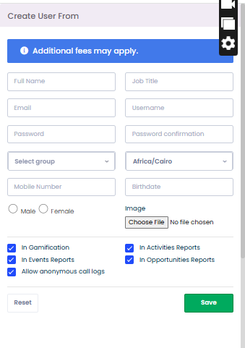
the Rest are not much used
this is the new version settings
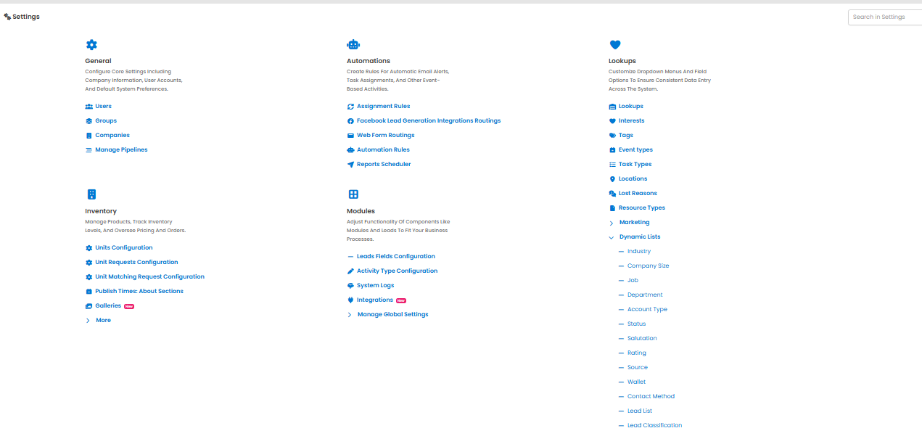
we need to add attachment file for sales and leaders to upload reservation and done deals documnts on crm without giving them acesses to edit lead
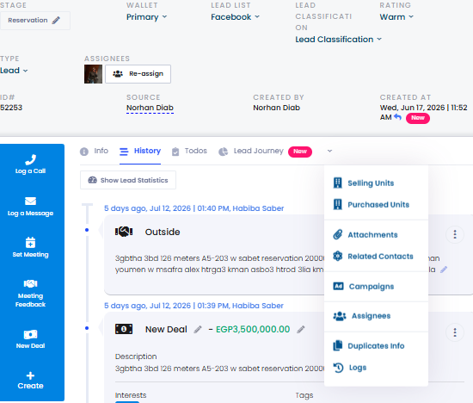
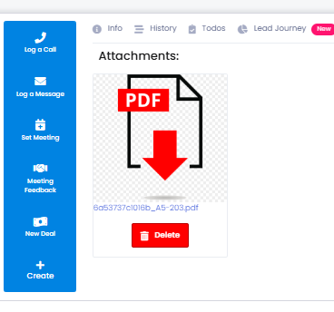
its only made by operations and Gm Thru edit
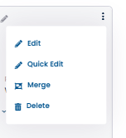
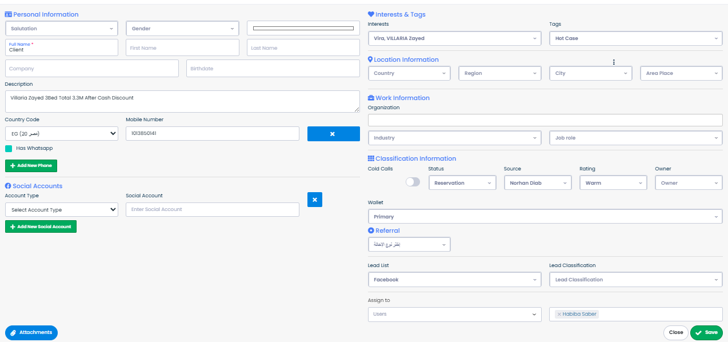
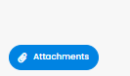 | 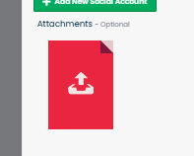
we also need marketers to have acesses to add description inly after adding leadif client needs specific instructions for contact withous acesses to edit
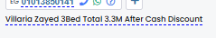
and also we need a bigger range
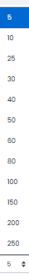
as For Actionss
we have two things
1 laptop actions does not have change stage with the actions
so like call action there is no icon for changing stage with our permission they can do seperate actions ( Call action , then change stage )
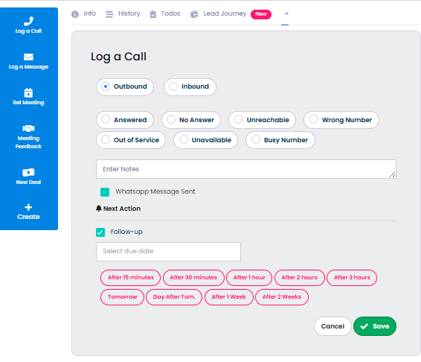 | 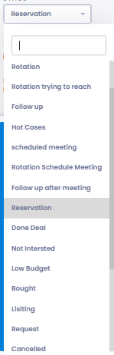 | 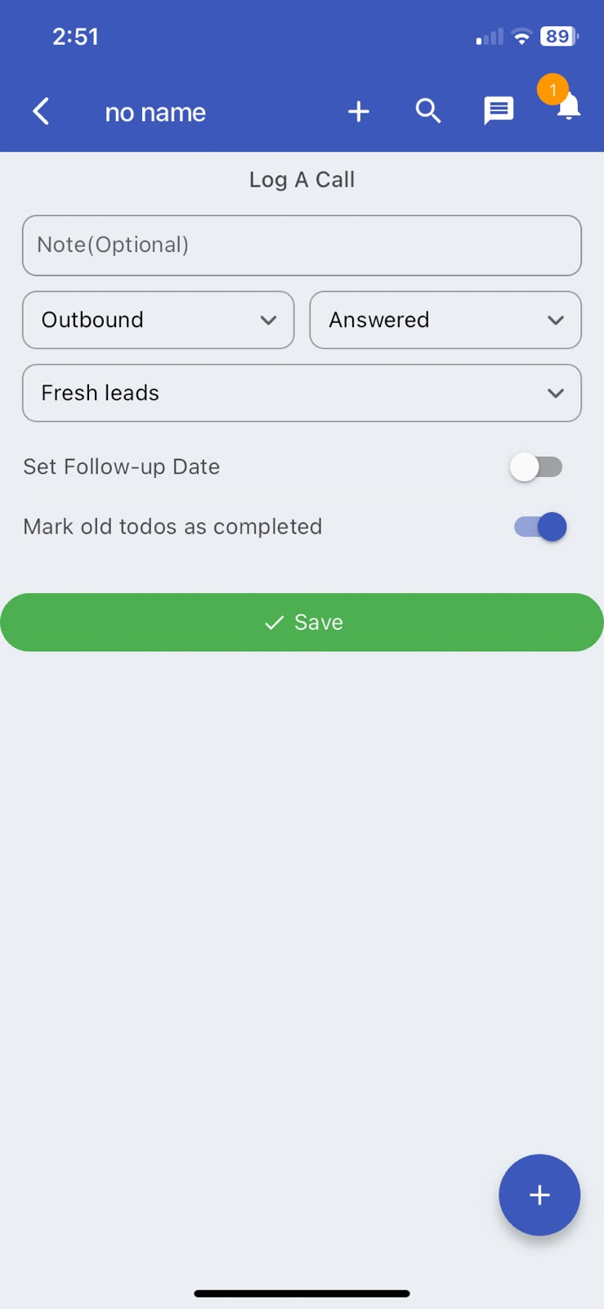
2- message
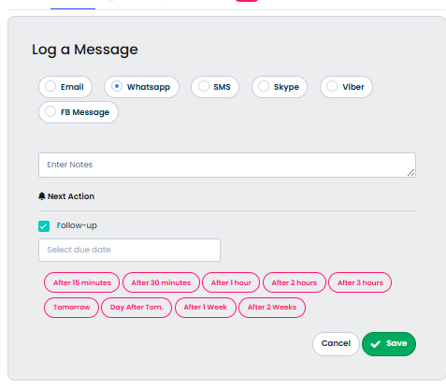 | 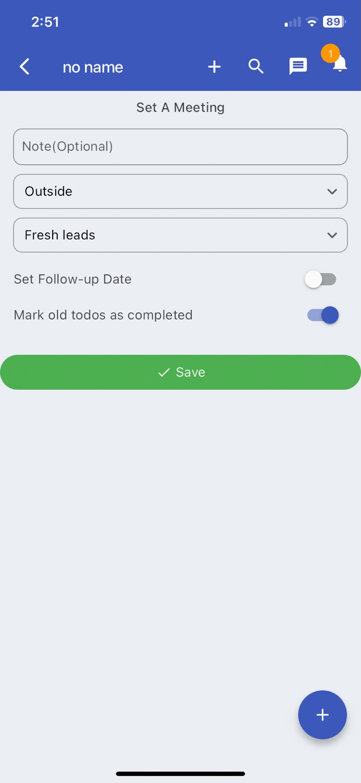

3- set a meeting
this is a lot different than the mobile app action
Laptop Action Vs : Mobile APP Action
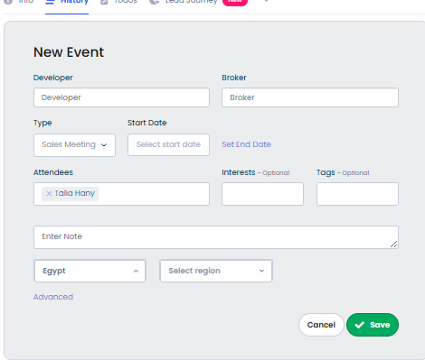 | 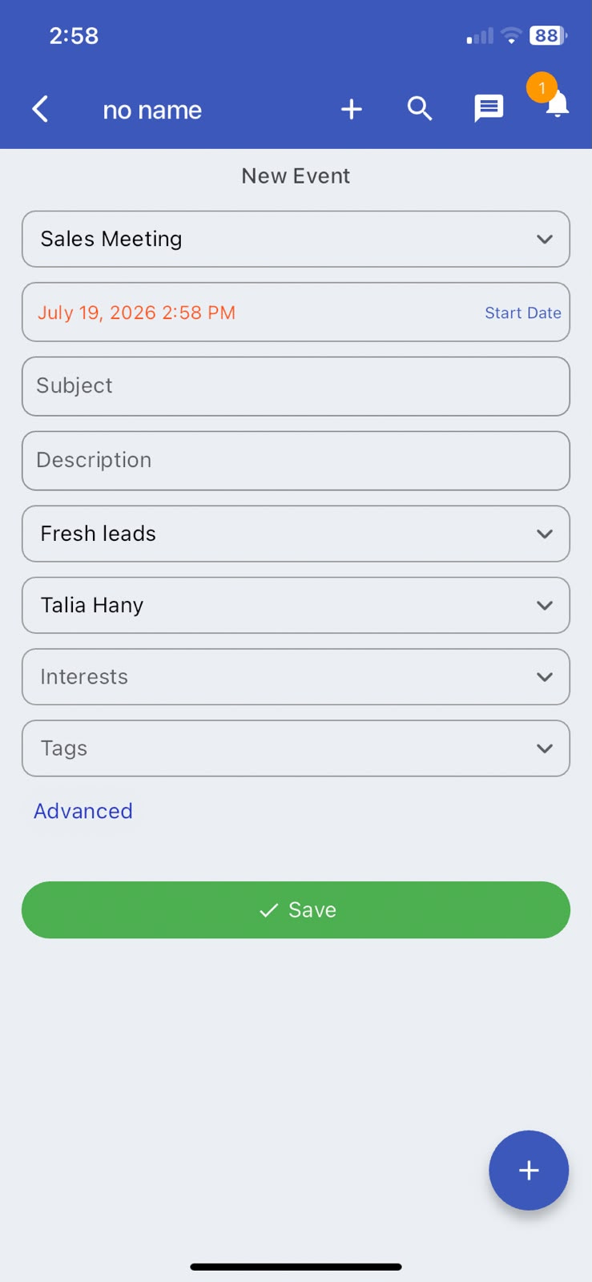
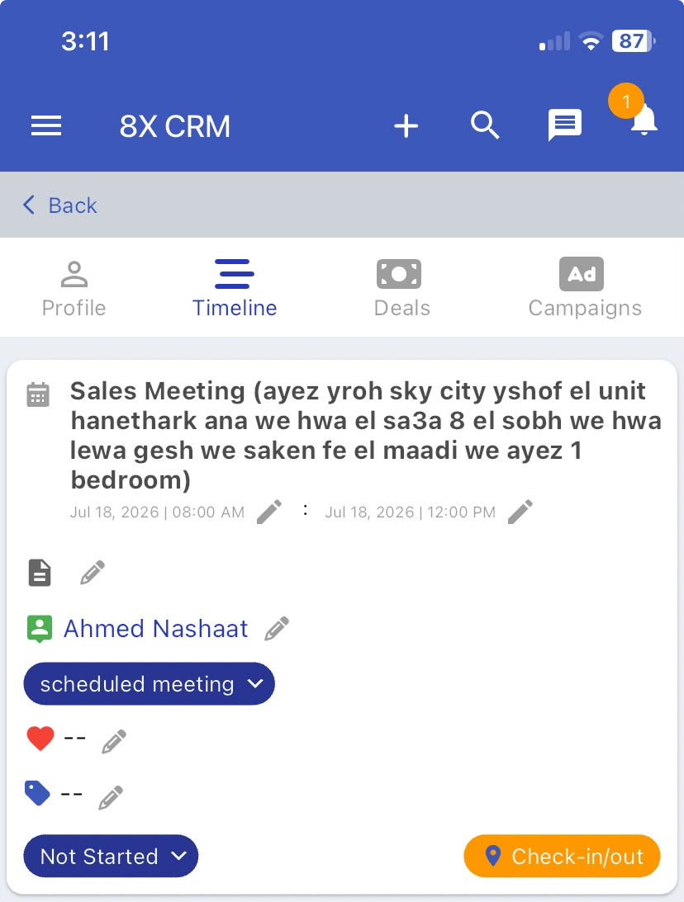

and check in & out from app and the not started action
4- new Deal
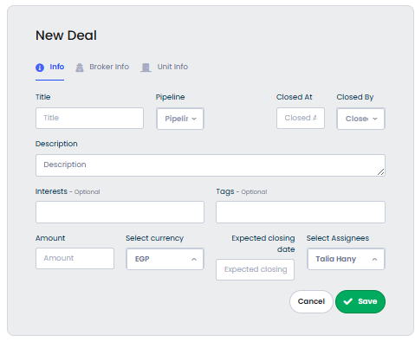 | 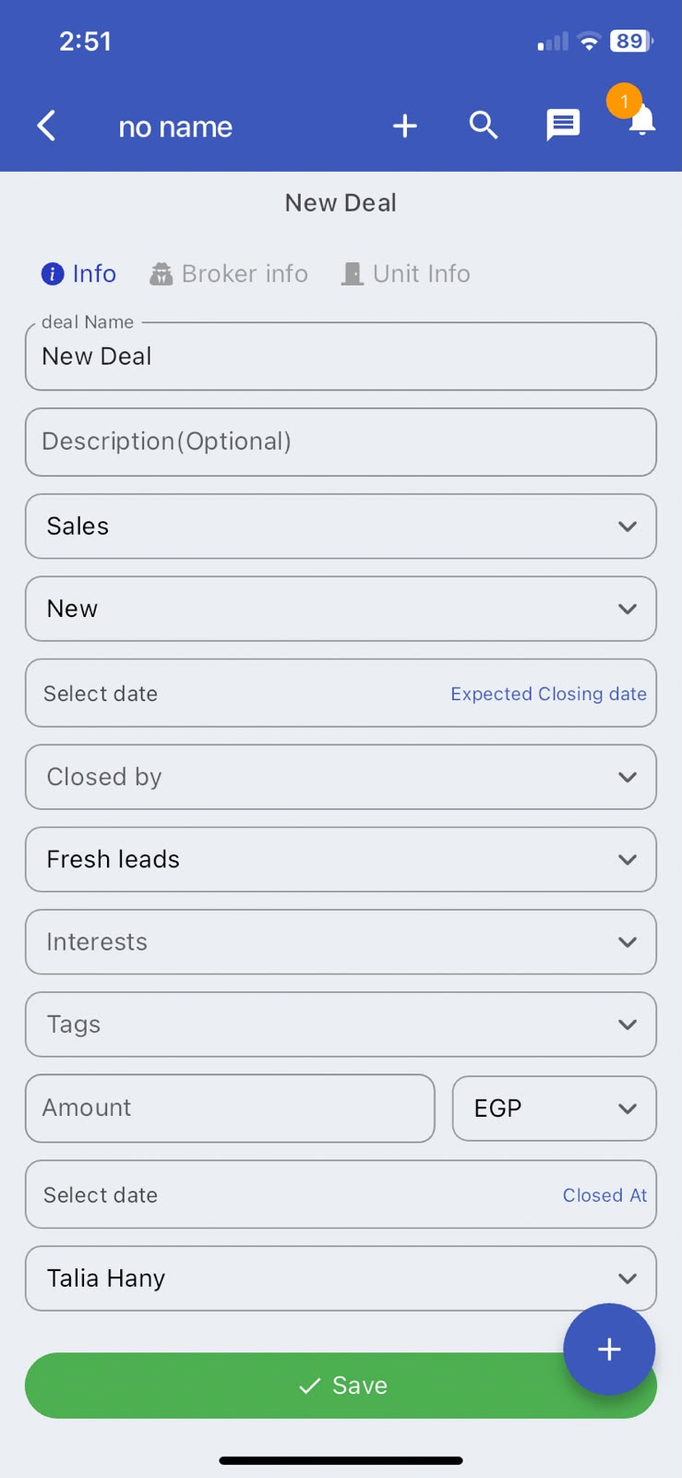
5 Meeting Feedback
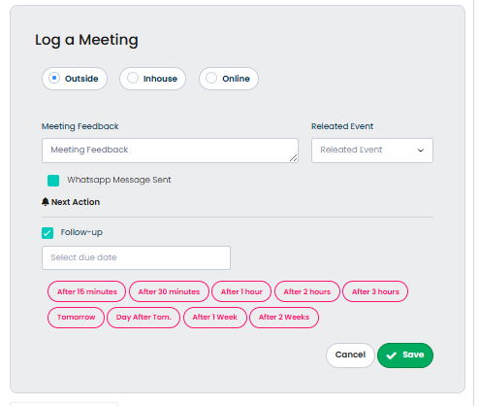 | 
in every two pics w find the follow date in App is optional & web is the contrary

